Landing page / THE GEOGRAPHY OF LEARNING

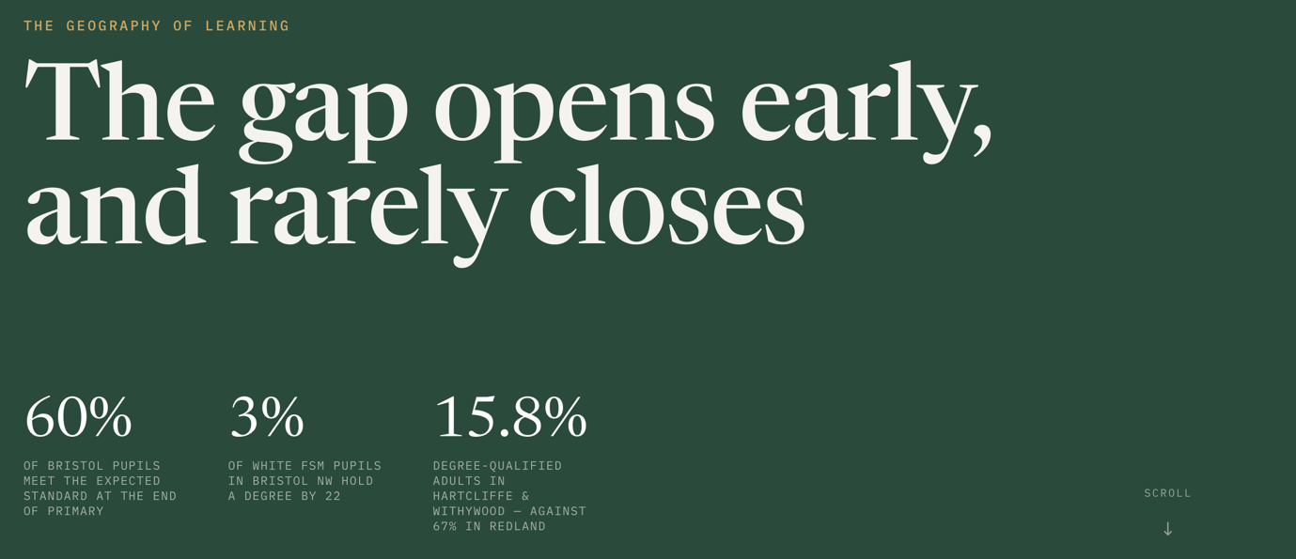

[title text] Attainment gaps shaped by disadvantage open early and rarely close

Stat 1, key messsage:

Significantly fewer disadvantaged children are ‘school ready’.

49.9%

of children eligible for free school meals (FSM) in Bristol are school ready, compared to 74.5% of children who are not eligible for FSM.

Stat 2, key messsage:

Achievement declines during primary school



68.7%

of Bristol pupils reach a good stage of development in Reception, tracking the national average of 68.3%, but only 60% of pupils reach the expected level at the end of primary, relative to an average of 63% in England.

Stat 3, key messsage:

Levels of persistent absence from school are extremely high in Bristol



24.7%

of pupils in the city are persistently absent, missing at least 10% of their school sessions. This is among the highest rates in England.

Stat 4, key messsage:

Disadvantaged pupils are far less likely to access higher education


3%

of white FSM pupils in Bristol North West hold a degree by the age of 22. In the deprived ward of Hartcliffe and Withywood only 15.8% of adults have a degree compared to 67% in the affluent ward of Redland.

Page 2 / A TALE OF TWO CLASSROOMS

[title text] Bristol is the most highly qualified core city in the UK, but it is also a place where extreme educational inequality persists

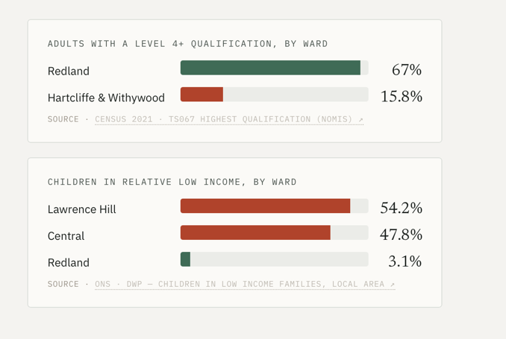
Stark within-city disparities can be seen in the number of adults achieving Level 4+ qualifications in Bristol’s lowest (Redland) and highest (Hartcliffe & Withywood) areas of deprivation.

Some of the city’s most deprived areas are home to the highest proportions of children. Growing up in low-income households and deprived areas affects young people’s access to opportunities.

